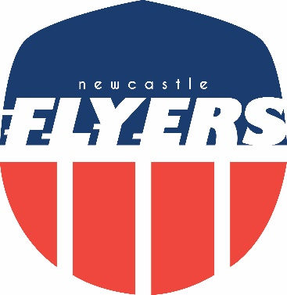

Flyers Awards 2020

“Favourite Photo”
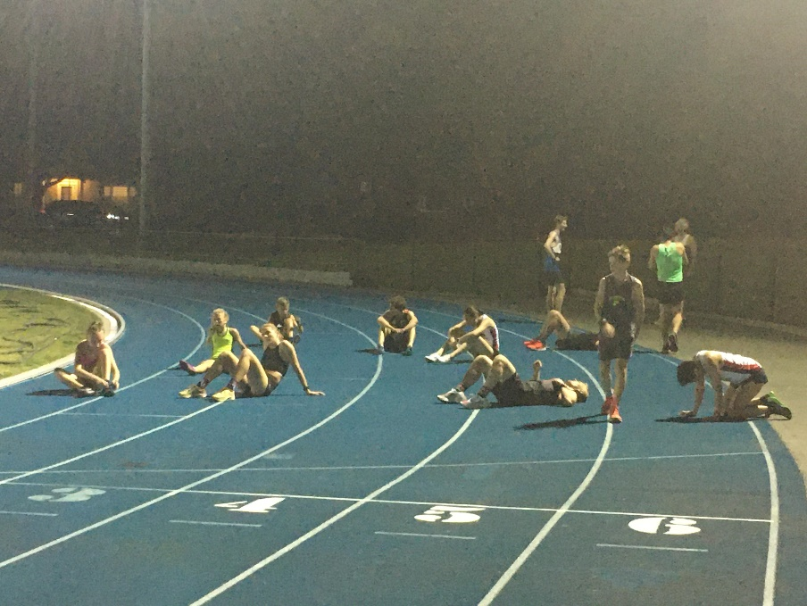
THE AFTERMATH

Picture: Matt Mahony

Flyers Awards 2020

“Most memorable long run”
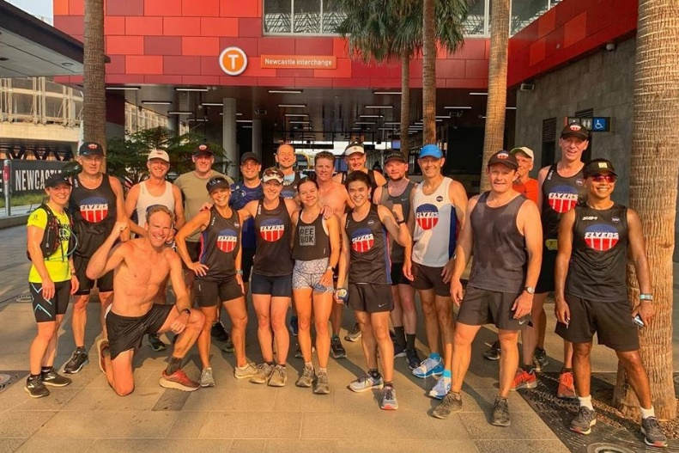
Trains on a Train

Flyers Awards 2020

“Inspirational Achievement”

​Dave Robbo

Run streak: 30-Dec-2016 to 03-Jul-2020 for 1282 consecutive days

