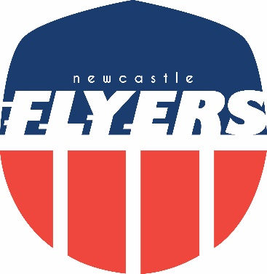

Flyers Awards 2019

“Underachiever of the Year”

Paul Murray
For Consistent Under Performance (Repeat Winner )

Flyers Awards 2019

“Favourite Photo”
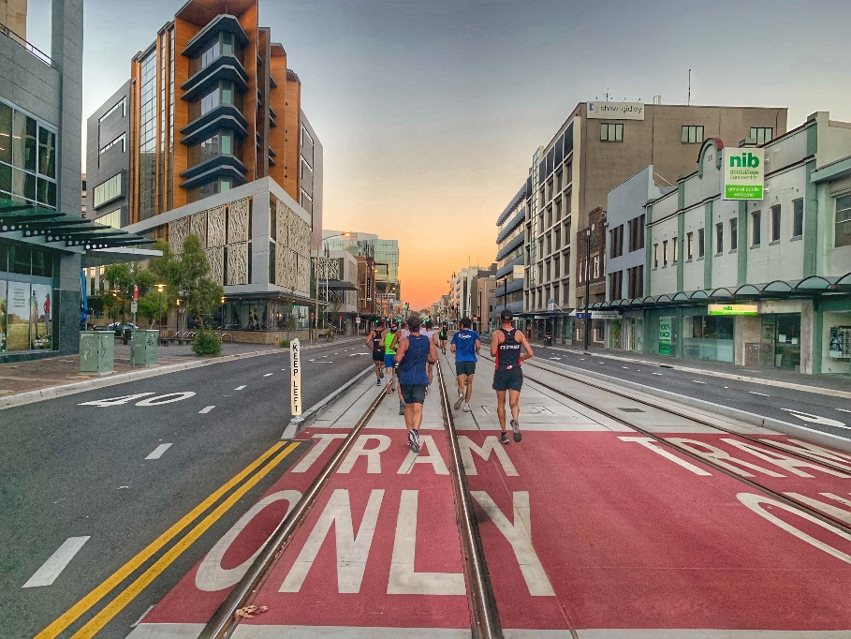
TRAM ONLY
(day before opening)

Picture: Dave Robbo

Flyers Awards 2019

“Most memorable long run”
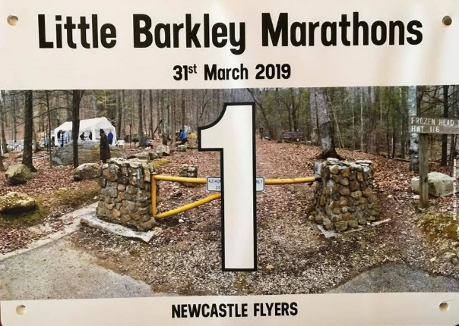
Little Barkley Marathons
Matt Mahony

Flyers Awards 2019

“Best Race Report”

​Kim Rackemann
Blackmores Sydney Running Festival Marathon

