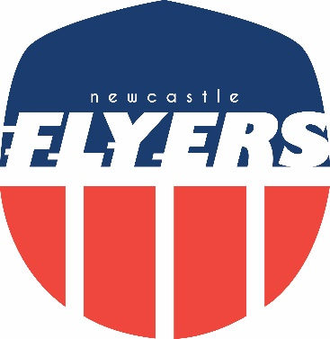

Flyers Awards 2022

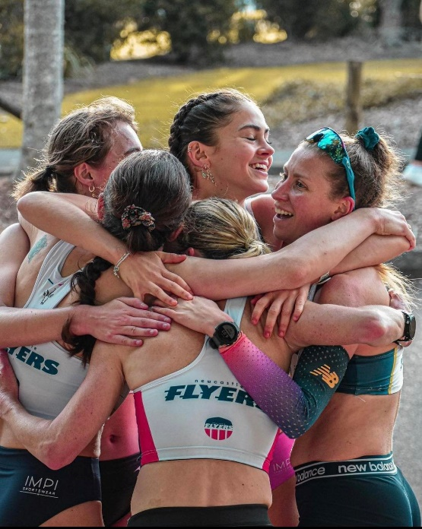
“Favourite Photo”

Relay Champs Joy
Picture: Jenny’s coaches’ son

Flyers Awards 2022

“Most memorable long run”
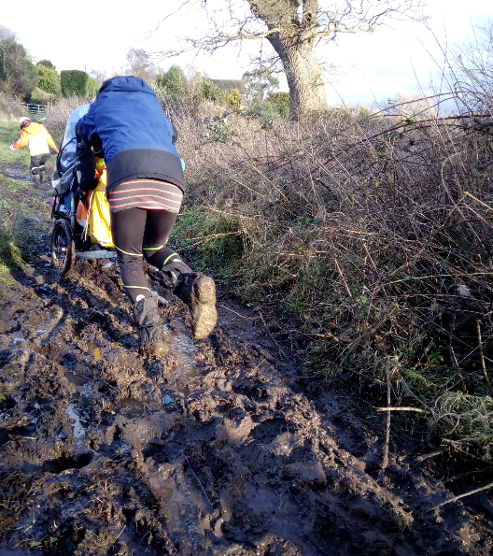
Mark Allen loses half of Blue train
- Amelia does Munibung Hill 😬🙈

Run Leader: Mark Allen

