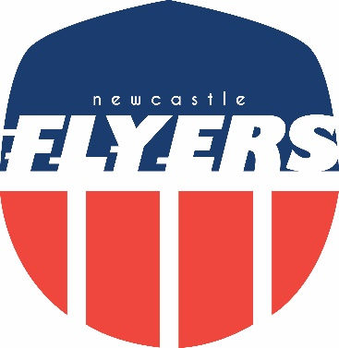

Flyers Awards 2021

“Favourite Photo”
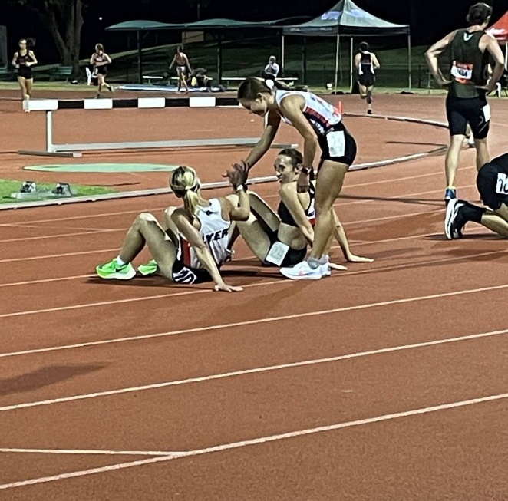
Champions
champion
each other
Picture: Jess’ Mum

Flyers Awards 2021

“Most memorable long run”
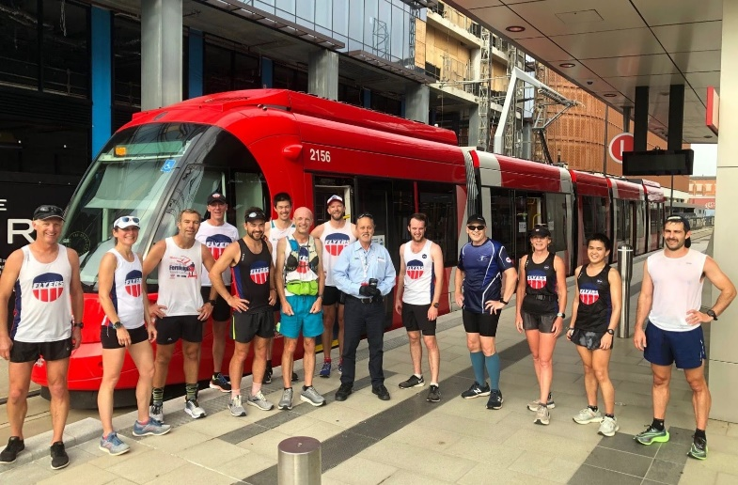
Race the Tram 🚋

Run Leader: Michael Ovenstone

