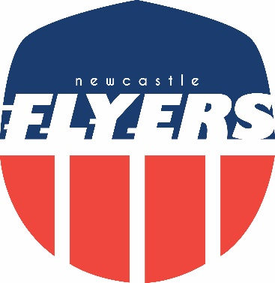

Flyers Awards 2018

“Underachiever of the Year”

Arnold Bartlett
For Consistent Under Performance

Flyers Awards 2018

“Favourite Photo”
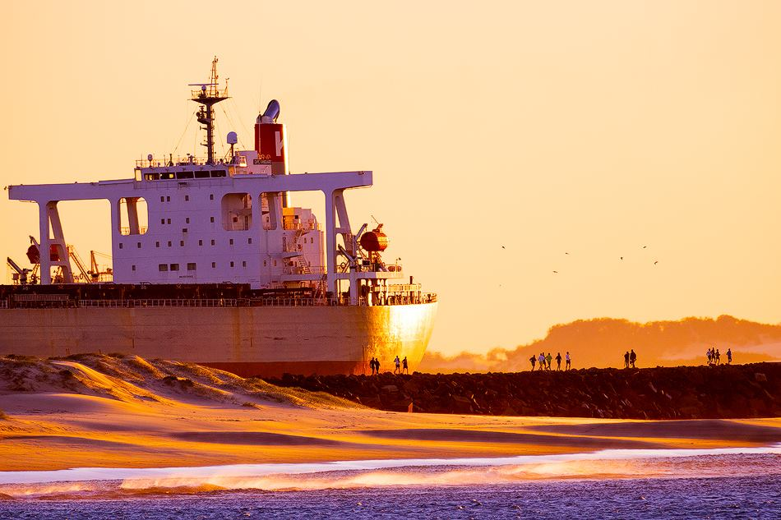

Break-wall Blue Train

Picture: David Diehm Photography

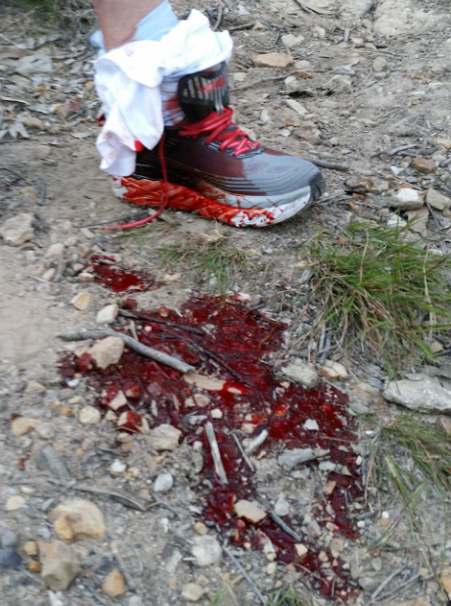
Flyers Awards 2018

“Most memorable long run”

Damo's "Blood" Train

Flyers Awards 2018

“Best Race Report”

Laura Mihé Simon
Blackmores Sydney Running Festival Marathon

