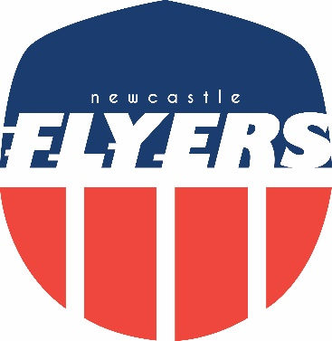

Flyers Awards 2017

“Underachiever of the Year”

Paul Murray
For consistent under performance

Flyers Awards 2017

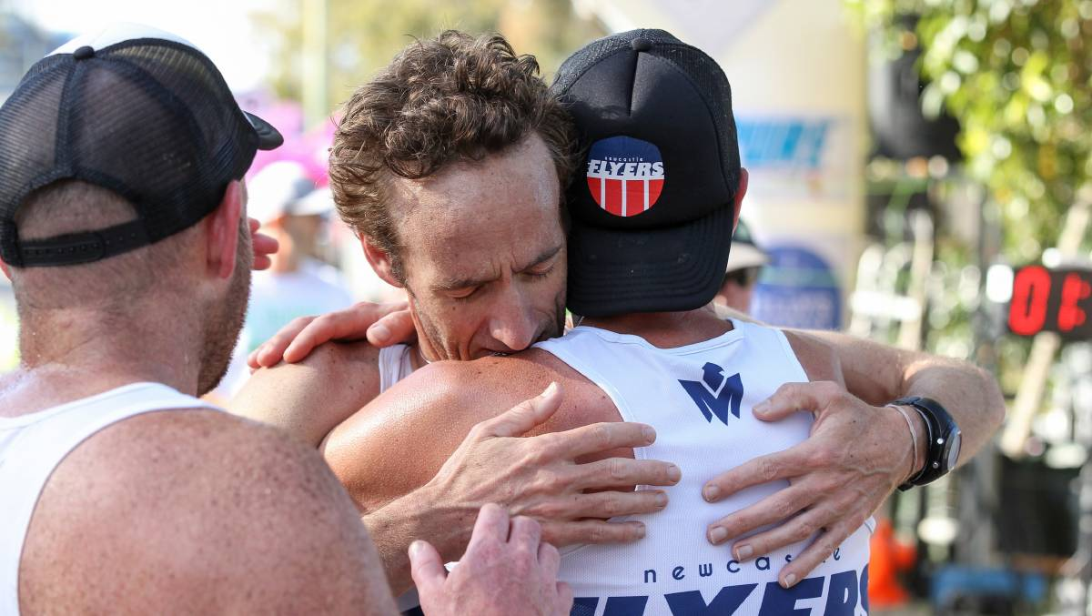
“Favourite Photo”

Jordi, John & Josh
Picture: Max Mason-Hubers

Flyers Awards 2017

“Most memorable long run”

Jordi & Robbo
Run in remembrance for Jen Bates

Flyers Awards 2017

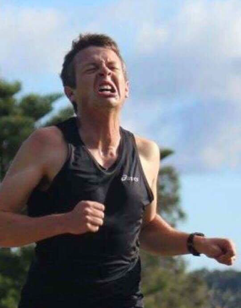
“Running is so glamourous”

James Eather
Ow – that hurts

