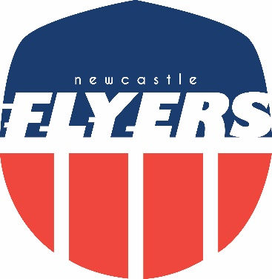

Flyers Awards 2016

“Sometimes running is hard”

Regina Jensen
Melbourne Marathon

Flyers Awards 2016

“Infringement and misdemeanours”

John Doyle
Bib swapping saga

Flyers Awards 2016

“Most memorable long run”

Josh Griffith
Valentine’s Day hill repeat and Maddison Drive special

Flyers Awards 2016

“Running is so glamourous”
John Doyle
Pizza Pacman

